Experiment 2

Aim: To study and explore MySQL Workbench and understand its usage for database creation, SQL query execution, database design, and basic server management in a MySQL environment.

Theory:
MySQL and RDBMS
MySQL is a popular open-source Relational Database Management System (RDBMS) that organizes data in the form of tables made up of rows and columns. This tabular structure enables efficient storage, retrieval, and management of data. Interaction with the database is performed using SQL (Structured Query Language).
In this experiment, we concentrated on two major types of SQL commands:
- DDL (Data Definition Language):
These commands are used to define and modify the database structure. The key DDL command applied in this experiment was CREATE TABLE, which is used to design the table schema by specifying column names and their respective data types.
  - Data Types: Appropriate data types such as VARCHAR (for variable-length text), DECIMAL (for precise numeric and monetary values), and DATE (for storing date information) were used.
  - Constraints: Constraints like PRIMARY KEY were implemented to uniquely identify each record, for example, ACTNO in the DEPOSIT table and LOANNO in the BORROW table.
- DML (Data Manipulation Language):
These commands handle operations on the data stored in the database. The INSERT INTO command was utilized to add specific records to the tables.
MySQL Workbench
MySQL Workbench is an integrated visual tool designed for database designers, developers, and administrators. It offers a user-friendly graphical interface (GUI) that allows users to design databases, manage connections, and execute SQL queries efficiently without depending entirely on command-line operations.

Task 1: To study DDL-create and DML-insert commands.
- Create tables according to the following definition.
  - CREATE TABLE DEPOSIT (ACTNO VARCHAR2(5), CNAME VARCHAR2(18), BNAME VARCHAR2(18), AMOUNT DECIMAL (8,2), ADATE DATE);
  - CREATE TABLE BRANCH (BNAME VARCHAR2(18), CITY VARCHAR2(18));
  - CREATE TABLE CUSTOMERS (CNAME VARCHAR2(19), CITY VARCHAR2(18));
  - CREATE TABLE BORROW (LOANNO VARCHAR2(5), CNAME VARCHAR2(18), BNAME VARCHAR2(18), AMOUNT DECIMAL (8,2));

- Insert the data as shown below.

DEPOSIT
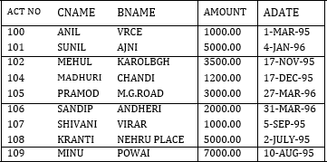

BRANCH
Branch_name | City_name
Vrce | Nagpur
Ajni | Nagpur
Karolbagh | Delhi
Chandi | Delhi
Dharmpeth | Nagpur
MG Road | Bangalore
Andheri | Mumbai
Virar | Mumbai
Nehru Place | Delhi
Powai | Mumbai

CUSTOMERS

CNAME City_name
Anil Calcutta
Sunil Delhi
Mehul Baroda
Mandar Patna
Madhuri Nagpur
Pramod Nagpur
Sandip Surat
Shivani Mumbai
Kranti Mumbai
Naren Mumbai

From the above given tables perform the following queries:

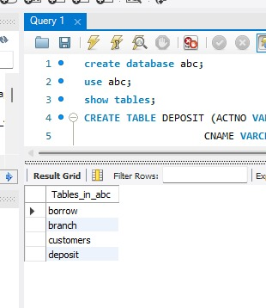

- Describe branch.

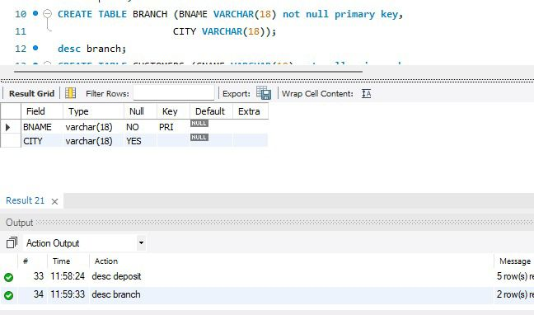

- Describe deposit.

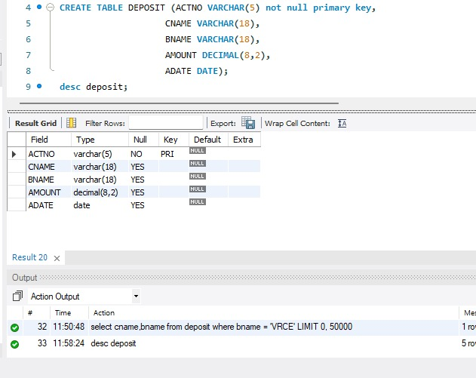

- Describe borrow, customers.

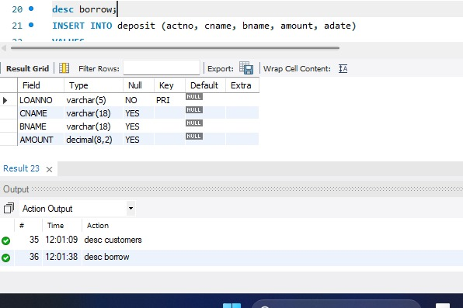

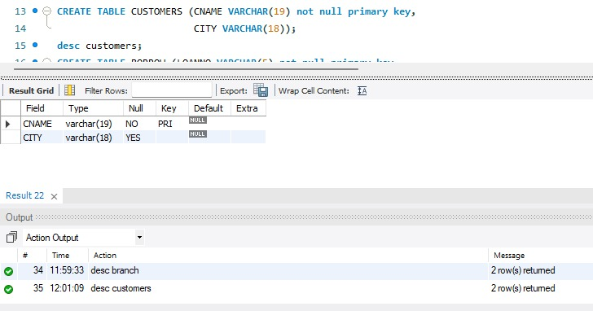

- List all data from table DEPOSIT.

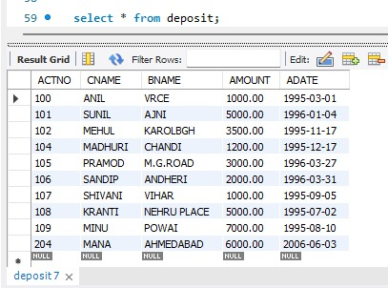

- List all the data from the table BORROW
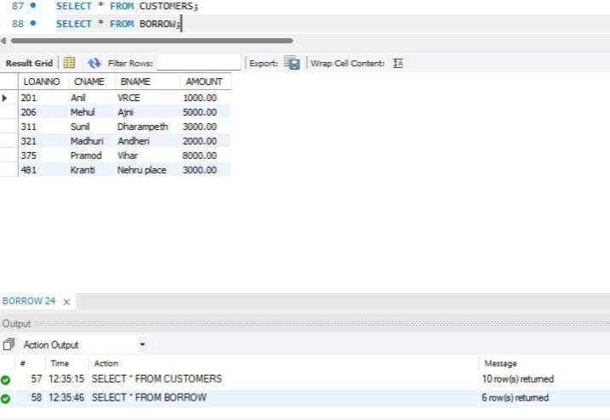

- List all data from table CUSTOMERS.

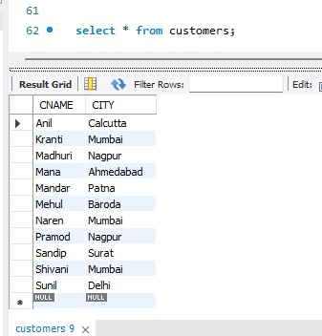

- List all data from table BRANCH.

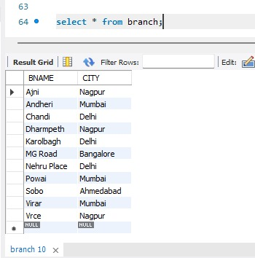

- Give account no and amount of depositors.

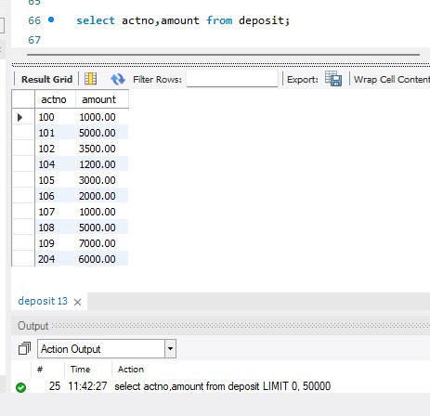

- Give name of depositors having amount greater than 4000.

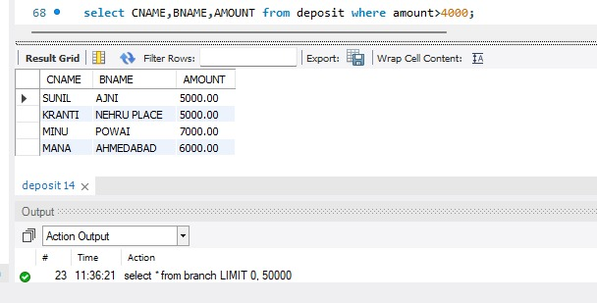

- Give name of customers who opened account after date 'give any date'.

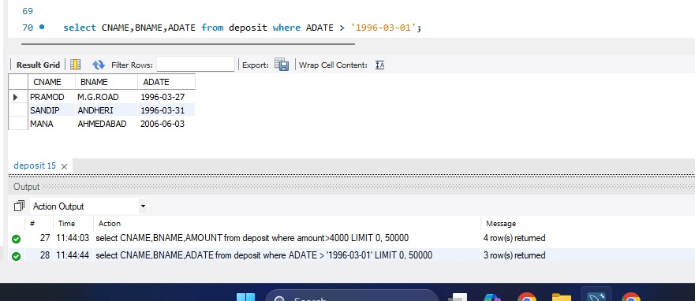

- Give name of city where branch karolbagh is located.

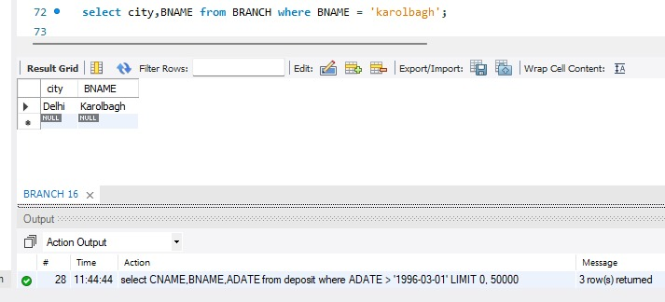

- Give account no and amount of customer having account opened between date 'give any date’ and 'give any date’.

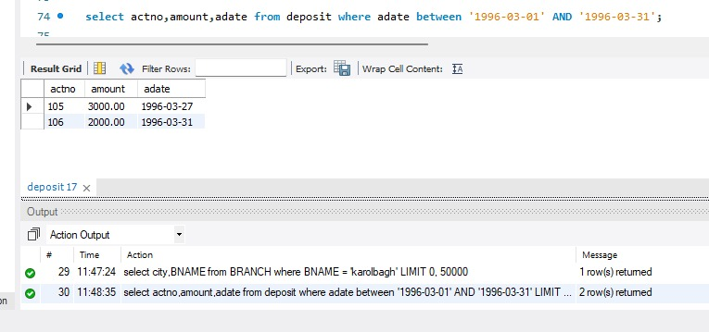

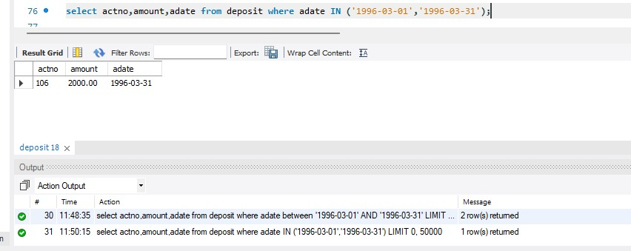

- Give names of depositors having account at VRCE

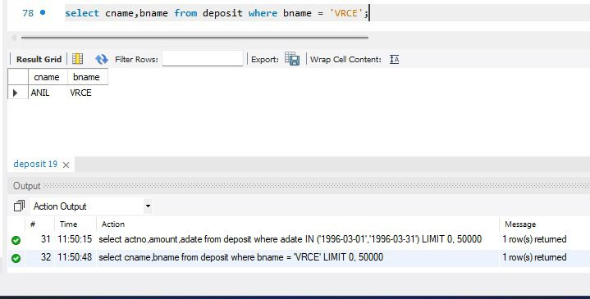

Conclusion:
In this experiment, we effectively examined and gained practical experience with the MySQL Workbench environment. The following tasks were carried out successfully:
- Database Structure Creation: Four tables—DEPOSIT, BRANCH, CUSTOMERS, and BORROW—were designed and created using the CREATE TABLE command (DDL), with suitable column specifications and primary keys.
- Data Insertion: The tables were populated with the given data set using the INSERT INTO command (DML).
- Data Validation: The accuracy of the table creation and data insertion was confirmed by executing SELECT queries to display all records from the DEPOSIT and BORROW tables.
Hence, this experiment helped us understand the fundamental operations of MySQL Workbench, including database creation and the execution of basic DDL and DML commands.

